

Lab Journal: 07
Date: 10/30/2025

Student : Lotfullah Muslimwal
Enrollment : 01-131232-039

Department of Software Engineering

Bahria University, Islamabad

Visual Programming-Lab (Fall-2025)
Teacher: Engr. RAHEELA AMBRIN

Task No: | Task Wise Marks |  | Documentation Marks |  | Total Marks  (20)
 | Assigned | Obtained | Assigned | Obtained
1 | 3 |  | 5
2 | 3
3 | 3
4 | 3
5 | 3

Comments:

Signature

Lab No: 07 - Lab Title: Menus

Tools Used
- Visual Studio
Task 6.1:
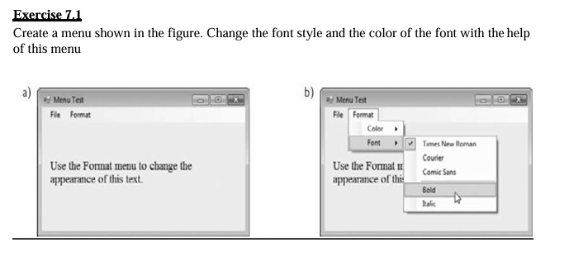
Code: Task 1 Code
Screenshot
- Without any change
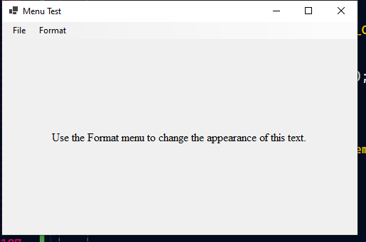

- Change the color to the Red

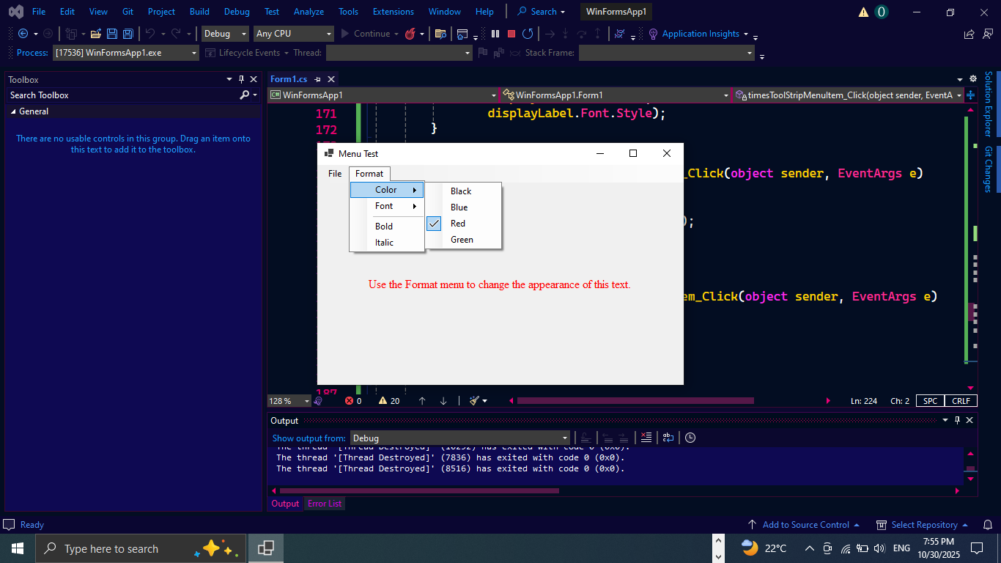

- Change the Font

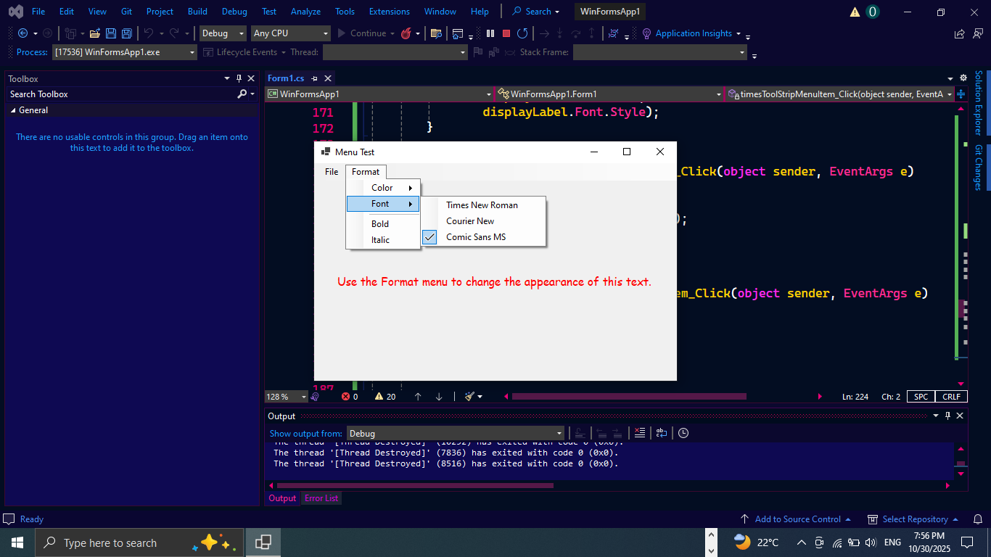

- Make the Text Bold
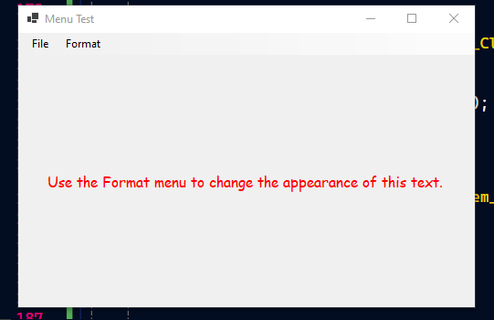

GitHub repository: Code For Lab 7
Conclusion:
We made a simple Windows program with a menu.
Using the Format menu, you can:
- Change the text color to Black, Blue, Red, or Green.
- Change the font to Times New Roman, Courier New, or Comic Sans MS.
- Turn Bold and Italic on or off.
All this was done only with code — no dragging or dropping anything in the designer.
The program starts with normal black text in Times New Roman. When you click any menu option, the text changes right away and a checkmark shows your choice.

